Implementation of a Multi-Server Architecture using DNS, NFS, Web Server, and MariaDB

Vishal menariya

22etccs170

Wordpress

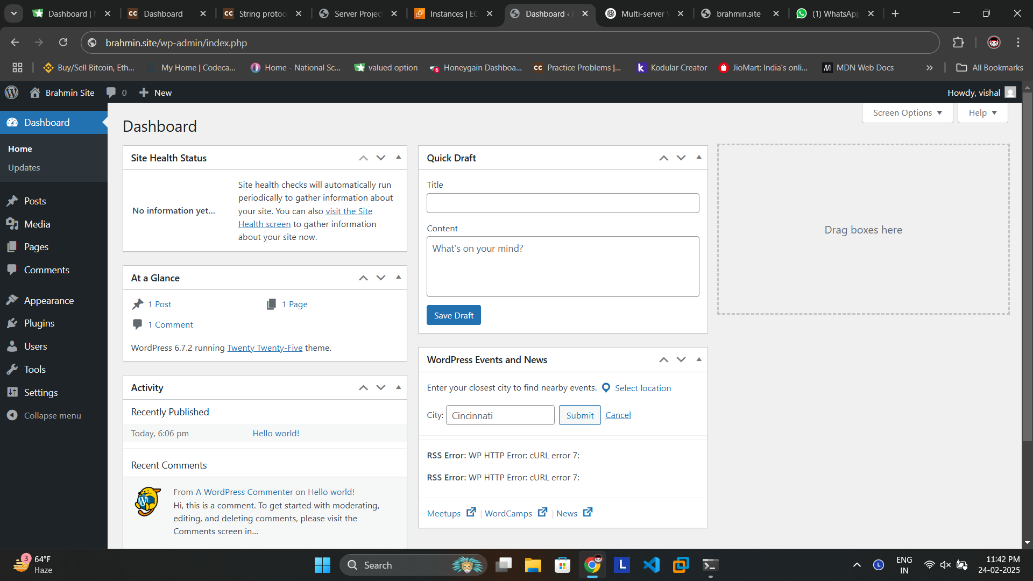

Dns

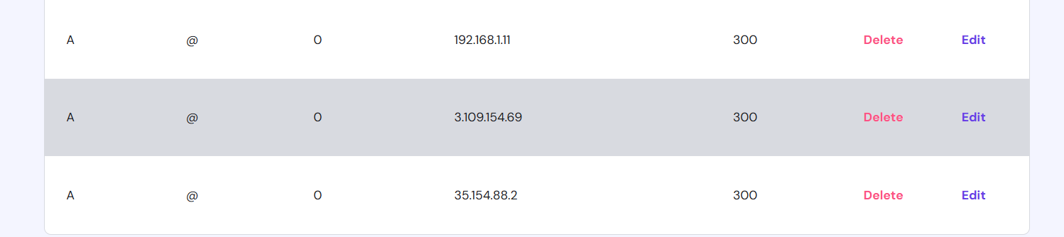

Wordpress files

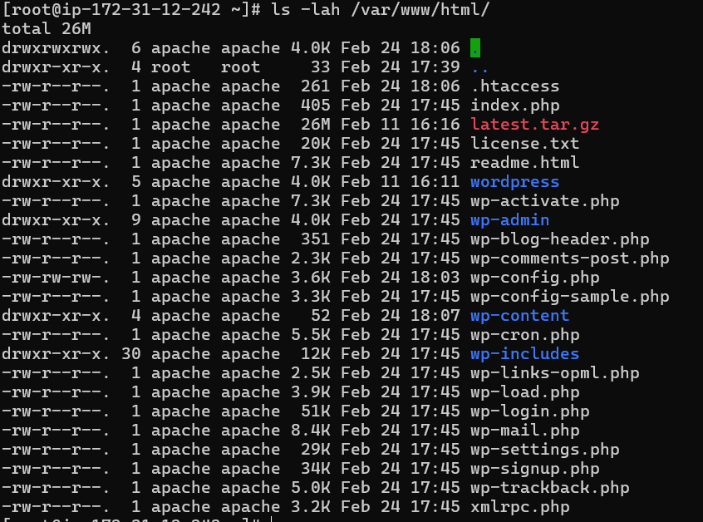

Databases

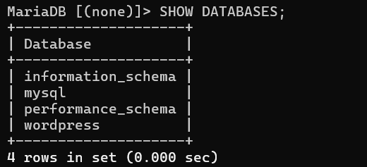

Replication config master

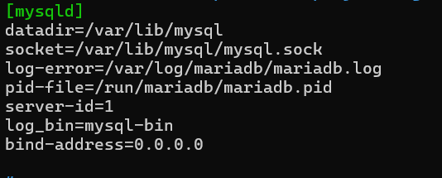

Database connection test

